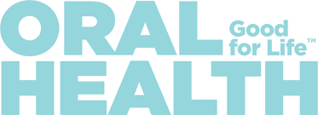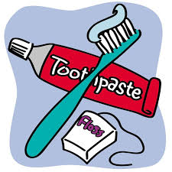

Good oral health contributes positively to your physical, mental and social well-being and to the enjoyment of life's possibilities, by allowing you to speak, eat and socialize without pain, discomfort or embarrassment.

Jump start lifetime habits by making these healthy kids teeth goals:

Limit sugary snacks. ...
Brush twice a day. Brush for them, with them, then beside them. ...
Floss and mouth rinse daily (per age appropriateness)
Make brushing fun with a musical timer. ...
Explain why brushing is important. ...
Visit the dentist twice a year.
A special toothbrush can go a long way.
Make oral health a fun habit!

A fluoride mouth rinse program is available in participating elementary schools throughout New Brunswick in partnership with the Department of Education and Early Childhood Development. Research has shown that fluoride mouth rinse programs are effective in reducing cavities by as much as 20 to 30 percent.
http://www2.gnb.ca/content/gnb/en/services/services_renderer.201235.Fluoride_Mouthrinse_Program.html

Healthy Smiles, Clear Vision is New Brunswick’s dental and vision plan for children of low-income families
http://www2.gnb.ca/content/gnb/en/departments/social_development/promos/healthy_smiles_clear_vision.html

Fredericton Education Centre, Anglophone School District- West
Healthy Learners in Schools Program

